MHP and Homeowners Association Asset Management Program
This template is intended for small, community public water systems. It incorporates the Asset Management Plan requirements in Ohio Administrative Code Rules 3745-87-03 and 3745-87-05.

Public Water System Name: PWS ID: OH0500112 Date: 4/29/2022
Public Water System Description

Ground water Surface water
Ground water purchased Surface water purchased
Number of Service Connections: 91 Source: Ground Water Source Type:
Residential Population: 167 Non-Residential Population: 15
Interconnections: (List, if applicable)

Water System Usage

The water usage in the next 5 years is expected to:
Increase Decrease Stay the Same
Average Daily Demand (gpd): 12,421 Hours per day the system runs: System capacity:
Limiting Factor for System Capacity:
Contact Information

1
Contact Type | Name | Phone | Email | Current Address
Owner | Gary Goosman | 740-777-4621 | amesvillemayor@gmail.com | Box 213 Amesville, Ohio 45711
Manager | Same | same | same | same
Financial Contact | Tabitha Keirns | 740-448-2411 | Fo.amesville@gmail.com | same
Operator | Lee Van Dyke | same | gleemaster@gmail.com | same
Sampler | Lee Van Dyke | same | gleemaster@gmail.com | Same
Maintenance | Same | Same | Same | same

MHP and Homeowners Association Asset Management Program
2
Operating Plan
Describe or attach your succession plan for critical personnel. Attach any cooperative agreements and service contracts.
Table of Organization
Complete the following table.
Title | Job Duties/Responsibilities | To whom does this person report? | Training Attended | Credentials
Owner | Gary Goosman, Mayor | Council | RCAP | Mayor
Manager | Same | Same | Same | Same
Financial Contact | Tabitha Keirns | Mayor | Same | Attorney of Law
Operator | Lee Van Dyke | PWS Operator | EPA | Class 1
Sampler | Lee Van Dyke | Assistant Operator | Same | Class A
Maintenance | Same | Same | Same | same

Significant Deficiencies
Has Ohio EPA cited any significant deficiencies for your public water system that are unresolved? Yes No
If yes, list the significant deficiencies here and attach the letter(s) from Ohio EPA which includes the director approved schedule to correct each significant deficiency.

MHP and Homeowners Association Asset Management Program
3
External Contacts
If a water system has this information included in their Contingency Plan required by Chapter 3745-85-01 of the Administrative Code, they are able to refer to its location in their Plan.
Refer to page (fill in page number) in Contingency Plan.
Contact Type | Name | Day Time  Phone Number(s) | After Hours Phone Number(s) | Email
Ohio EPA District Office | Eric Hart |  | 1-800-282-9378 | Eric.Hart@epa.ohio.gov
Ohio EPA Emergency Response |  | 1-800-282-9378 | 1-800-282-9378
Police | Amesville Police | 740-448-2411 | 740-591-0721
Fire Department | AAB Fire Department | 740-448-7235 | 911
County EMA Director | Athens EMA | 740-594-2261 | 911
Contractors for Line Breaks | JC Trivett | 740-448-1329
Electric Power Supplier | AEP
Electricians | Drake Chamberlain |  |  | <drake.chamberlin@gmail.com>
Well Drilling and Pump Service Contractors | Smith Brothers
Mechanical Contractors | TAM
Equipment and Chemical Suppliers | Thornburg Inc.
Ohio EPA Certified Laboratories | MASI
Local Health Districts | Athens County | 740-594-5722
OHWARN |  | 419-966-3624

Contracting and Purchasing Procedures for Water System Repair and Replacement.
(describe below or attach policy)
Routine Purchases | Thornburg Inc
Emergency Purchases | Athens Water System

MHP and Homeowners Association Asset Management Program
4
Written Policies
(describe below or attach policy)
 | Attached | Description (if no attached policy)
Security | X
Use of System Equipment |  | By authority of the Mayor or Water System Operator
Purchasing Authority |  | By authority of the Mayor or Water System Operator
Billing practices and revenue collections | X

Metrics
Year: | 2018 | 2019 | 2020 | 2021 | 2022
Operating Ratio
Operating cost to produce water per service connection:
Breaks per 10 mile of distribution pipe: | 5 | 4 | 2 | 2 | 2
Non-revenue water (percentage loss) | 50% | 20% | 10% | 10% | 10%
Maintenance tasks per year (planned vs unplanned) on vertical assets:
One additional customer service metric to be tracked shall be determined by the water system: | Per customer use

Source Water Protection
Source Water Assessment review date: (required annually) 09/15/2018
Checklist reviewed every 5 years or if you have an endorsed plan, reviewed every 3 years or sooner if there is a specified review date in the endorsed plan.)

MHP and Homeowners Association Asset Management Program
5
Emergency and Contingency Planning
Include the water system’s contingency plan required in the Chapter 3745-85-01 of the Administrative Code as part of your Asset Management Program.
Schematic
Draw below by hand or attach a schematic of the major components of the water system including source, treatment, storage and distribution as applicable. If you’d like to create the drawing using Word’s line and shape tools, Be sure to save this form as well as the schematic file once you’re done.

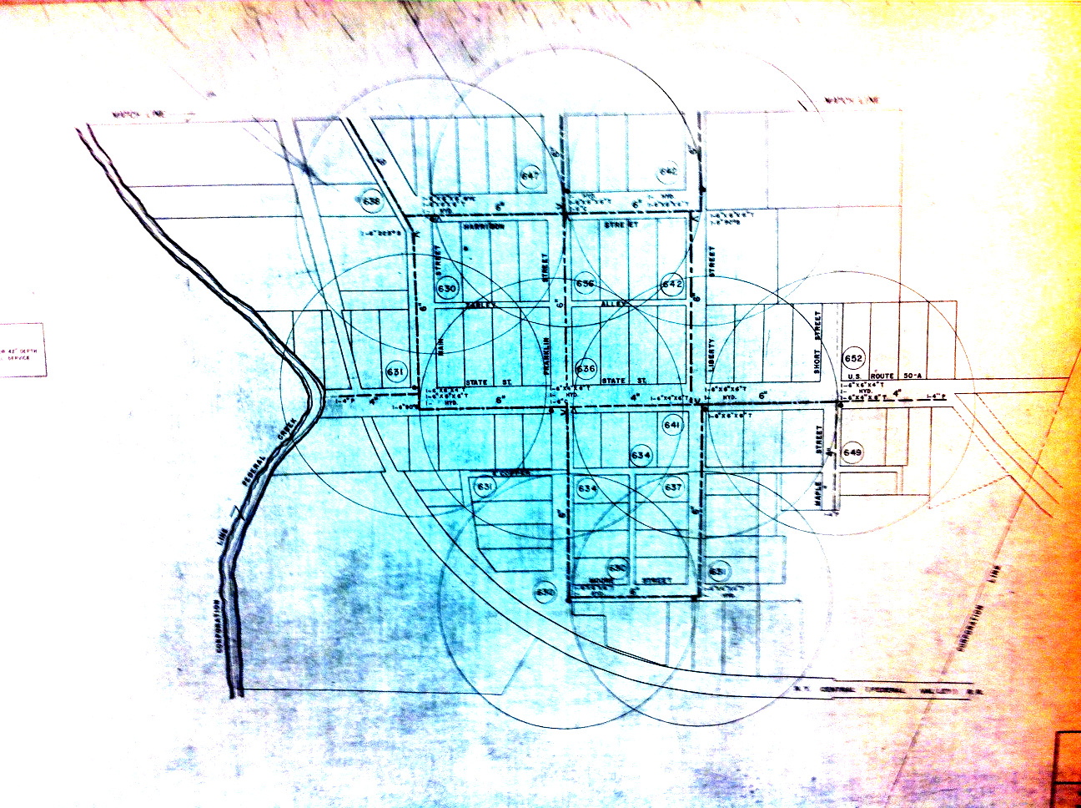
MHP and Homeowners Association Asset Management Program
6
Inventory of Assets
Assets that have a condition of very poor and poor should be in the timeline for rehabilitation and replacement and become projects in the capital improvement plan.
Asset Name | Purchase Date/Install ation | Life  Expectancy  (See Life Expectancy Table) |  | Estimated Age  (How old is the asset?) | Remaining Useful Life  (life expectancy - estimated age) | Status of Asset  (in use, available, needs repair) | Criticality | Rank Based on  Critical | Location² | Condition
Backflow Prevention | 2018 | 35-40 |  | 1 | 39 | Excellent
Blow-off Valves | 2018 | 35-40 |  | 1 | 39 | Excellent
Buildings | 2018 (rehab) | 30-60 |  | 1 | 39 | Excellent
Chlorination Equipment | 2018 | 10-15 |  | 1 | 14 | Excellent
Computers | 2021 | 5 |  | 4 | 4 | Excellent
Distribution Pipes | 1961 | 35-40 |  | 59 | 20 | Fair | High
Electrical Systems | 2019 | 7-10 |  | 1 | 9 | Excellent
Hydrants | 2018 (2) | 40-60 |  | 1 | 59 | Excellent
Lab/Monitoring Equipment | 2018 | 5-7 |  | 1 | 6 | Excellent
Meters | various | 10-15 |  |  | 14 | Fair
Other Treatment Equipment |  | 10-15 |  |  |  | Excellent
Pressure Tank 2018 |  |  | 7-10 Excellent
Pumps 2018 |  |  | 10-15 Excellent
Service Lines |  |  | 30-50 Fair: funding via EPA, OWDA, CDBG and OPWC is being sought.
Storage Tanks 2018 upgrade |  |  | 30-60 Excellent
Transportation Equipment None |  |  | 10
Valves 2018 |  |  | 35-40 Good: 70% of distribution valves have been replaced in 2018
Wells 1961 |  |  | 25-35 Excellent: wells were cleaned in 2019
¹Criticality = The largest number will have the greatest risk and should be prioritized for projects, etc. ²Attach a map showing the location of each asset.
Condition | Description
Excellent | In relatively new or new condition. The asset has required little to no maintenance.
Good | Acceptable condition. It still functions and requires minor maintenance.
Fair | Deterioration of the asset can be seen. It needs maintenance frequently to be able to perform.
Poor | Failure of the asset is likely and will be need to be replaced in the next few years.
Very Poor | Failure has occurred or is going to. Major maintenance is required or replacement needs to occur.

MHP and Homeowners Association Asset Management Program
7

Asset | Life Expectancy (years)
Backflow Prevention | 35-40
Blow-off Valves | 35-40
Buildings | 30-60
Chlorination Equipment | 10-15
Computers | 5
Distribution Pipes | 35-40
Electrical Systems | 7-10
Hydrants | 40-60
Lab/Monitoring Equipment | 5-7
Meters | 10-15
Other Treatment Equipment | 10-15
Pressure Tank | 7-10
Pumps | 10-15
Service Lines | 30-50
Storage Tanks | 30-60
Transportation Equipment | 10
Valves | 35-40
Wells | 25-35

Operation and Maintenance Programs:
Attach the operation and maintenance programs of water system assets.
These programs should be in accordance with Chapter 3745-83-01(H) of the Ohio Administrative Code and the following in accordance with the draft rules 3745-87-03(B)(4) of the Ohio Administrative Code:
(a) Standard operating procedures for daily operation of the facility.
(b) Maintenance schedules or supporting documentation of the maintenance performed for each of the following as applicable:
- Wells, all raw-water reservoirs and intakes.
- Pump stations.
- Electrical equipment and controls.
- Water treatment facilities.
- Water storage tanks and/or hydropneumatic tanks.
- Distribution system components, including hydrants and valves.
- Auxiliary power.
(c) Demonstration of an adequate maintenance log.

MHP and Homeowners Association Asset Management Program
8
Criteria and Timeline for Repair, Rehabilitation, Replacement and Expansion
(List criteria for determining repair, rehabilitation, replacement, and expansion below. These are determined by the public water system.)
Criteria
- Distribution lines installed 1958(needs system upgrade)
- Regular meter replacements

Timeline for Repair, Rehabilitation, Replacement and Expansion
Asset (Listed in order of priority) | Criteria Met  (# from Criteria list above) | Rehabilitation, Replacement, Repair, or Expansion? | Date To Be Completed | Funding Source(s)
Distribution lines and street valves | 1 | Replace | 2025 | ARC, CDBG, OPWC
Water meters | 2 | Replace 7 per year | On-going | Water fees
Computers (state donation every 4 years) | 3

Capital Improvement Planning
Attach three to five-year Capital Improvement Plans for the water system.
The Capital Improvement Plans (CIP) should include the following in accordance with the draft rules 3745-87-03(B)(16) of the Ohio Administrative Code:
- A CIP will include annual projections in three to five-year planning horizons with detailed expenditures in each of those time frames.
- The projects should be listed by the year in which they are planned and include, at a minimum, the following information:
- Description of the project.
- Need for, and benefits of, the project.
- Estimate of project cost, including design and construction.
- Funding sources.
Attach a description and estimated cost of significant projected projects for the next 10 to 20 years. Funding
System Debt: | 196,089
Reserve Account Amount:  (Should be enough to cover the system’s most important asset.) |  | 46,112.00
Number# of Months of Operating Monies on Hand: |  | 9
Fund: 5701 OWDA Design Loan Account Name Revenue Final Account Code Budget Budget Balance YTD % Received 5701-971-0000 Other Debt Proceeds $0.00 $0.00 $0.00 0.000% Fund 5701 Sub-Total: $0.00 $0.00 $0.00 0.000% Report
Total: $196,089.17 $196,817.10 $6,272.07 100.371

